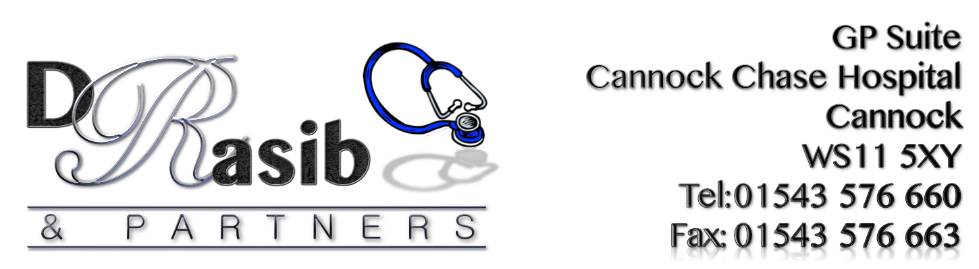

ACTION PLAN

Problems Identified | Action | Who is involved? | Timescales
Easily being able to get through to someone at the practice on the phone? | The Practice recognises that telephone contact is the preferred method of communication for patients with regards to contacting the surgery. However, this is adding to the level of telephone congestion that is being experienced by patients and therefore would like to encourage patients to book appointments using alternative methods that are available (patient access) which are just as convenient and result in the same outcome. The practice are therefore intending to further advertise online communication methods by advertising it on TV screen in waiting area, through leaflets that will be available for patients in the waiting area and also on the website. We are also offering patient access training sessions for those patients who may need help with using this method and PPG members have offered to help with raising awareness about Patient Access too. Sarah (PPG member) will be doing a display about patient access for the notice board situated in the waiting area and has offered to help with the training too. Sarah has seen the benefits of using patient access so is happy to share her experience with other patients.  It has been recognized that most of the patients are experiencing difficulties getting through between 8-9am and this is inevitable given the fact that the practice are experiencing a large number of calls during this time due to Same day appointments and patients calling to book these. We are hoping that the introduction of the pre-bookable appointments will help to reduce some of the traffic during the peak time and allow patients to get through quicker. The Practice continues to reiterate to all the reception/admin team the importance of answering all calls within 3 rings and not to put calls on hold but to offer ring back if the query will take a while to resolve. Unfortunately given the current financial situation at the practice and the options available to introduce a new phone system, we will be putting this option on hold at present. We have considered having more staff to cover phones during peak times but again due to the 52.5 hours that already have to be covered throughout the working week, this isn’t possible, as the staffing hours have to be distributed to cover the opening hours. | GP Partner  Managing Partner  All practice staff  PPG Member | On-going throughout the year
Introducing Pre-Bookable appointments | To allow patients to book up to 2 days in advance for limited/specified appointment slots. All such patients will be contacted the day before their appointment (and even the same day if it is a Monday evening). This will require all reception staff who are booking the appointments to ensure that the patient telephone contact details are up-to-date in order for reminder calls to be made.  Also now that the practice has a Pharmacist available, majority of their appointments will be pre-bookable appointments and available through Patient Access.  Also more appointments will also be made available as pre-bookable when we introduce an ANP (Advance Nurse Practitioner) in a few months time.  With most Reception staff now being trained as Care-Navigators, they will (where possible) try and signpost patients to other services where it is deemed appropriate. Hopefully this will free up some of the appointments for those patients who need to be seen by a Clinician at the practice.  The Practice will continue to use the DNA policy to reduce DNA’s so that further appointments can be made available to other patients who need them.  Practice also has plans to further expand the clinical team, this could include further GPs, another Pharmacist Practitioner, Physician Associate and maybe another ANP. | GP Partner  Managing Partner  All practice staff | December 2019  Completed  ✔  Plans for expanding the team with further clinicians will remain as part of an on-going plan.
Introducing a Text-Messaging Service | The practice will look at introducing a Text Messaging service which will allow staff to text patients asking them to contact the surgery etc. when they are unable to get hold of patients through the phone call method. Most patients who currently don’t answer their phones to ‘Unknown’ numbers will find this useful too. | GP Partner  Managing Partner | December 2019  Completed  ✔

